**Predicting Housing Prices Using Linear Regression.**

**Hamna Noor**

**Abstract**

It is important to predict the prices of houses before sales. The process varies depending on features like the number of rooms, location, area, and many others. Housing prices are strongly related to these factors. Machine learning algorithms can help us predict these prices with some accuracy. As a result, this paper applies linear regression model approaches to investigate the impact of various features on housing prices.

**Introduction**

House Price Index (HPI) is used to measure trends in housing prices in many countries. Machine learning models are widely applicable in different domains to predict future trends. We can predict house prices more accurately based on their attributes, regardless of the data from previous years.

I used the Housing dataset taken from Kaggle and the linear regression model to test and predict the prices. The relationship of different variables like the number of bathrooms, area, number of rooms, and location of the house was analyzed to study its dependency on the prices of houses.

**Experiments and Results**

**Experimental Setup**

I used the linear regression model on our dataset. Before doing that, I performed a statistical analysis to see the relationship between features and house prices.

The following plot shows the relationship between different features.

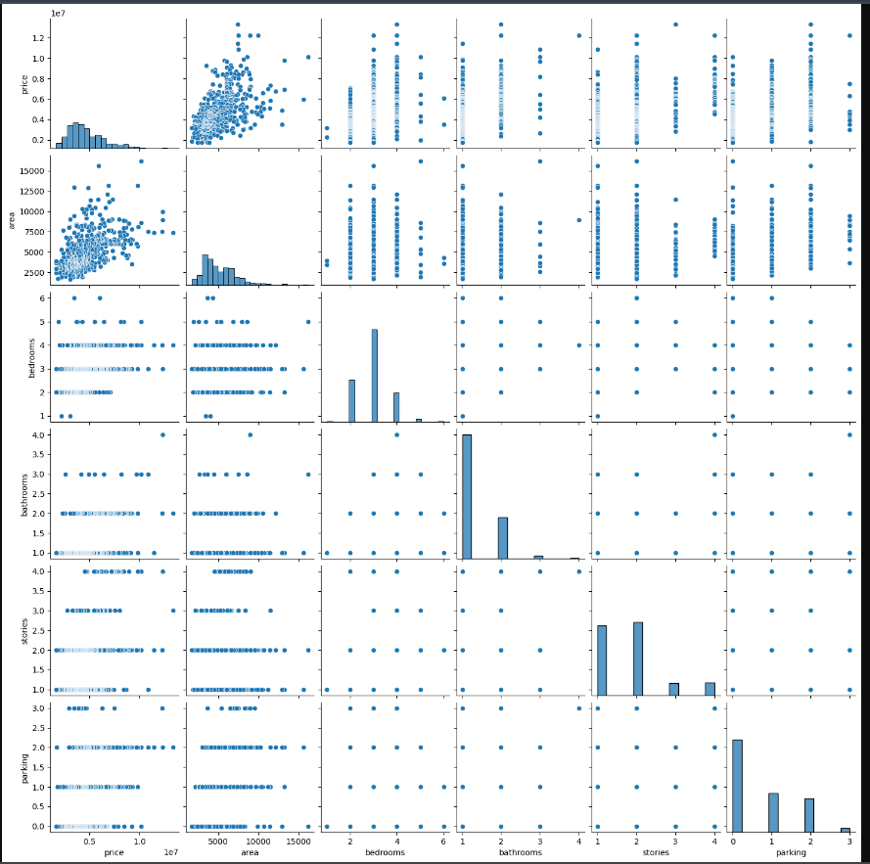

Figure 1 pairplot

It is important to study how different attributes are affecting housing rates. An in-depth analysis was done to check which features have more impact on prices than the others. For this model number of bedrooms, bathrooms, area, and the number of stores for analysis. The following plots explore their relationship with price.

Figure 2 Price Vs Area Figure 3 Price Vs bedrooms

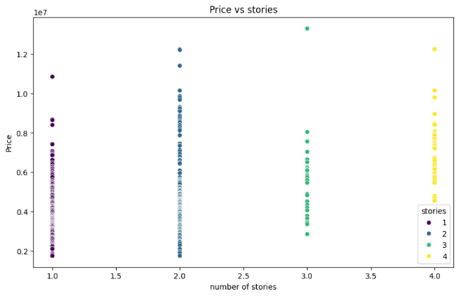

Figure 4 price Vs Stories Figure 5 price Vs Bathrooms

**Measures of Evaluation**

A comprehensive examination of the model’s performance was carried out using a variety of evaluation standards, including the F1-score, recall, accuracy, and precision.

**Results**

|  |
| --- |
| MSE= 2750040479309.0522  R2 = 0.4559299118872445  F1 score = 0.4559299118872445 |
| Figure 6 Result Analysis |

**CONCLUSION AND FUTURE WORK**

This experiment covers a detailed analysis of the Linear regression model on the housing data set. For future work, we can test the same dataset on other machine-learning models and compare the results.